Programming Challenge 10-2
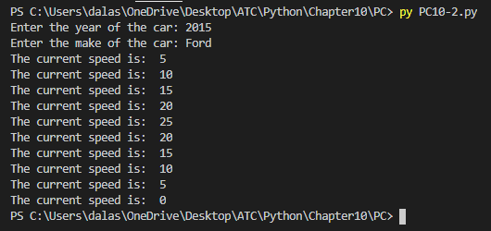

#car class program

class Car:
def __init__(self, year_model, make):
self.__year_model = year_model
self.__make = make
self.__speed = 0

def accelerate(self):
self.__speed += 5

def brake(self):
self.__speed -= 5

def get_speed(self):
return self.__speed

def main():
year = int(input('Enter the year of the car: '))
make = input('Enter the make of the car: ')

car = Car(year, make)

for i in range(5):
car.accelerate()
print('The current speed is: ', car.get_speed())

for i in range(5):
car.brake()
print('The current speed is: ', car.get_speed())

main()

